**WATER BILLING SYSTEM TECHNICAL GUIDE**

**Introduction**

* This is a small system that allows you to calculate the water bill easily. This system had been written using C Programming language. If we look at the programming code, this code has three functions.

1. Main Function
2. SamurdhiRecipients Function
3. NonSamurdhiRecipients Function

**Main Function**

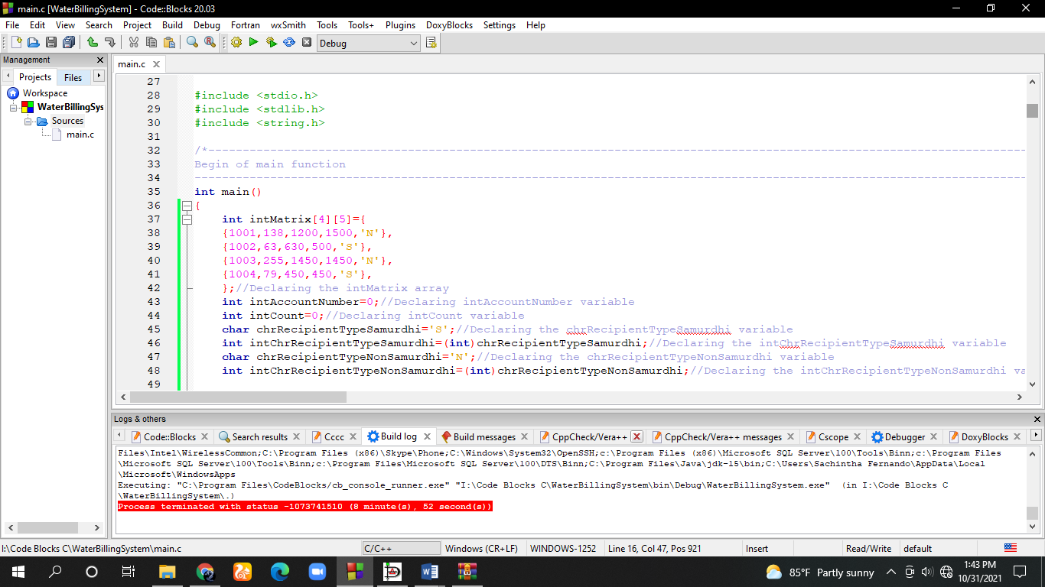

* In the beginning of the main function we have declared the “*intMatrix”* array. In this array we have stored the data like Account Number, Previous meter count, Previous bill amount, Previous bill payment and the recipient type which are necessary for our system.
* The samurdhi recipients represent by the letter “*S*” and the nonSamurdhi recipients represent by the letter “*N*”.
* After that we have declared the other variables like “*intAccountNumber*”, “*chrRecipientTypeSamurdhi*”, “*chrRecipientTypeNonSamurdhi*”, “*intCount*” which are necessary for our system.
* Then we declared the “*intChrRecipientTypeSamurdhi*” and “*intChrRecipientTypeNonSamurdhi*” assigned the Ascii value of “*chrRecipientTypeSamurdhi*”,“*chrRecipientTypeNonSamurdhi”* to them.

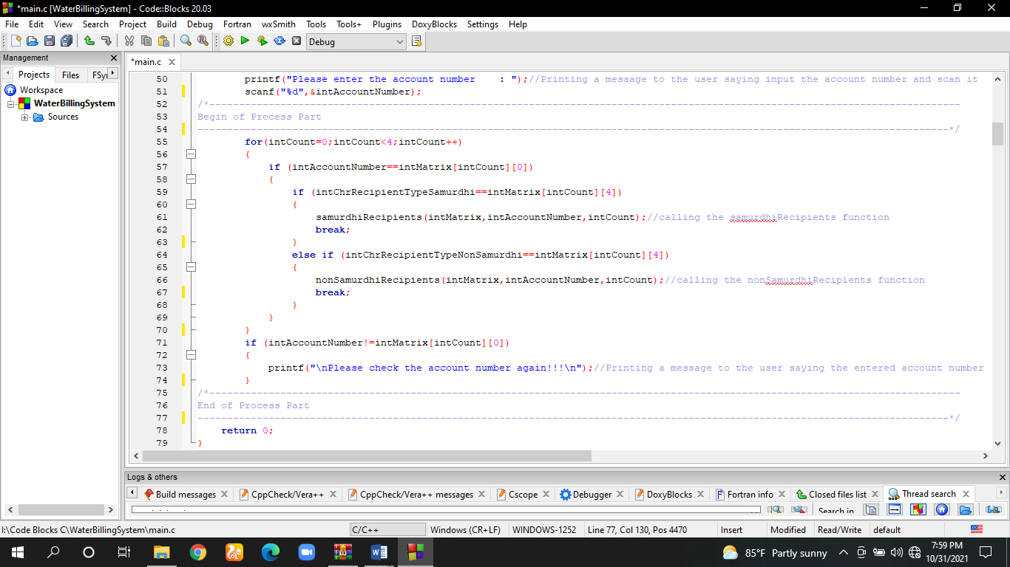

* In here we will output a message to the user saying *“Please enter the account number”.*
* We have used a for loop to repeat the checking of the equality of the user entered account number and the account numbers which are stored in the “*intMatrix*” array.
* For check that we have used the if condition. If the required condition is satisfied it will go inside the if condition otherwise loop will continue till the condition of for loop becomes false.
* If the for loop is unsatisfied then the user will get a message saying “*Please check the account number again!!!*”
* Inside the for loop if the if condition is satisfied again it will check the recipient type of the entered account number. For that again we have used the if condition.
* If the recipient type is “*S*” then the samurdhiRecipients function will be called and if the recipient type is “*N*” the nonSamurdhiRecipients function will be called.

**SamurdhiRecipients Function**

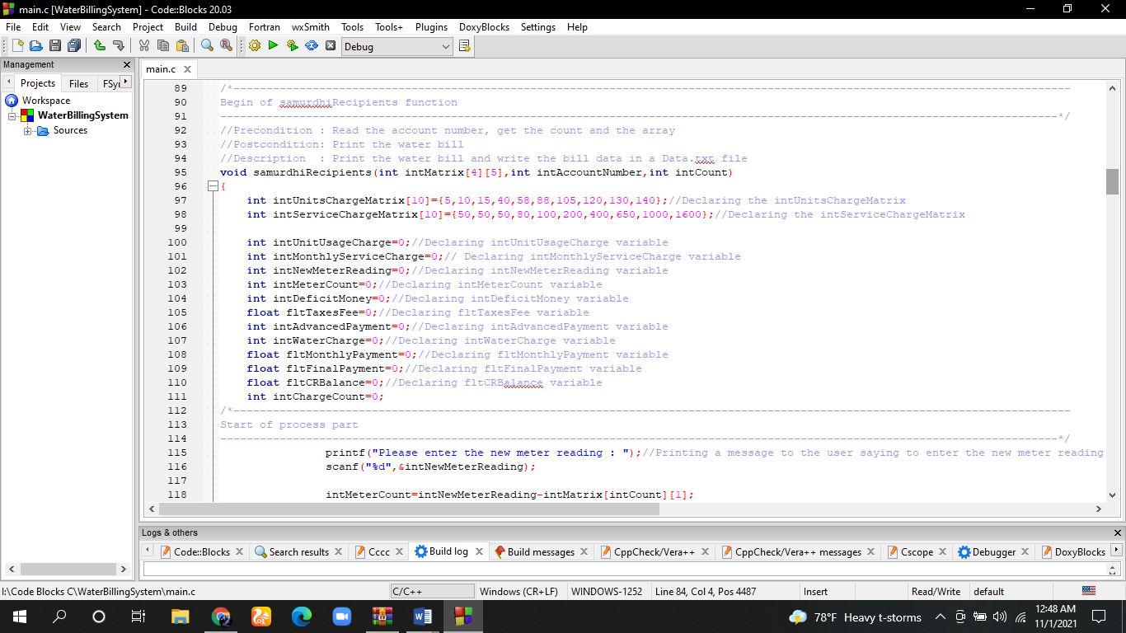

* In the beginning of this function we have declared two arrays *“intUnitsChargeMatrix”* and *“intServiceChargeMatrix”.* In them we have stored the units charges and service charges.
* After that we have declared the necessary variables like “*intUnitUsageCharge*”, *“intMonthlyServiceCharge”, “intNewMeterReading”* etc.

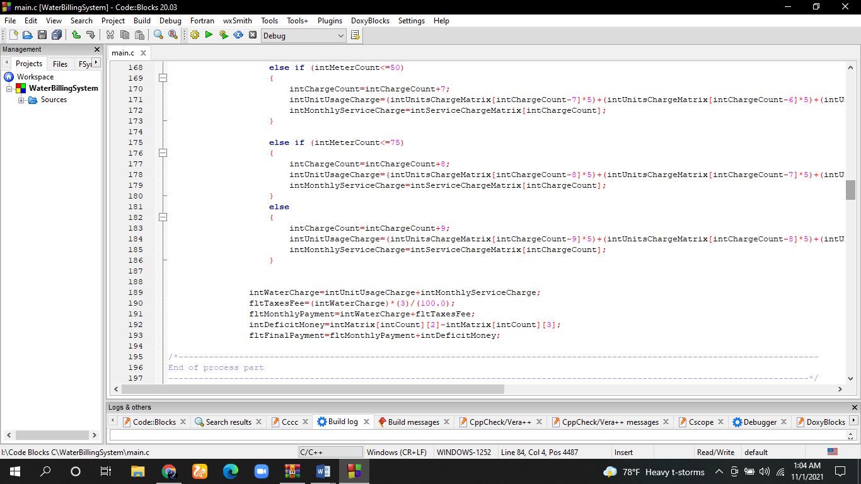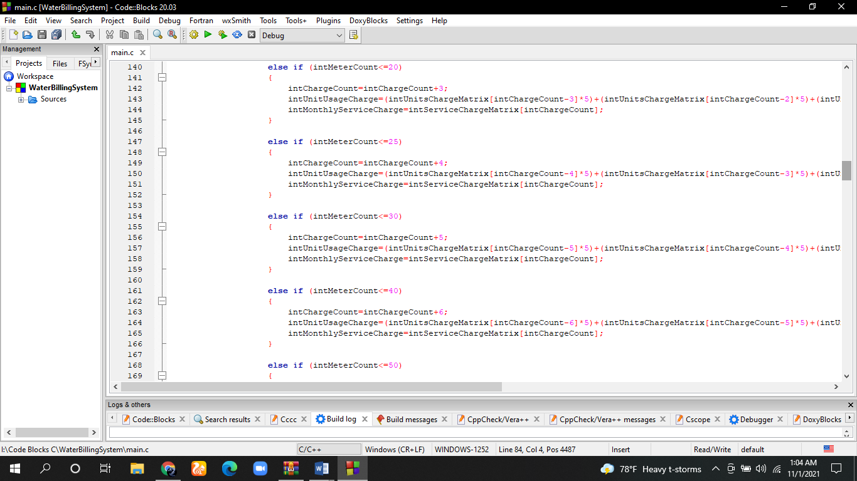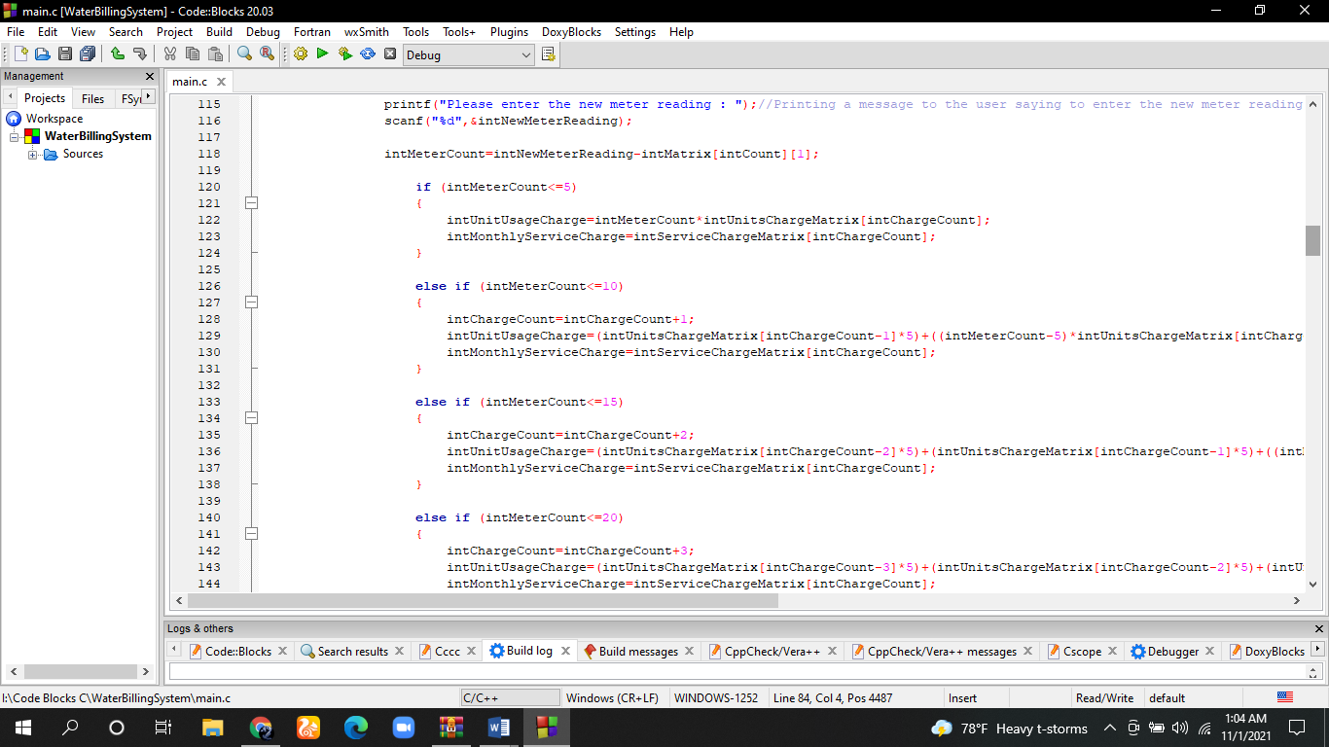

* After that we will print a message to the user saying *“Please enter the new meter reading”.* After getting the new meter reading we have calculated the consumption*(“intMeterCount”).*
* Then according to the consumption we have calculated the *“intUnitUsageCharge”* and *“intMonthlyServiceCharge”.*
* For select the correct units rates we have used the if condition.

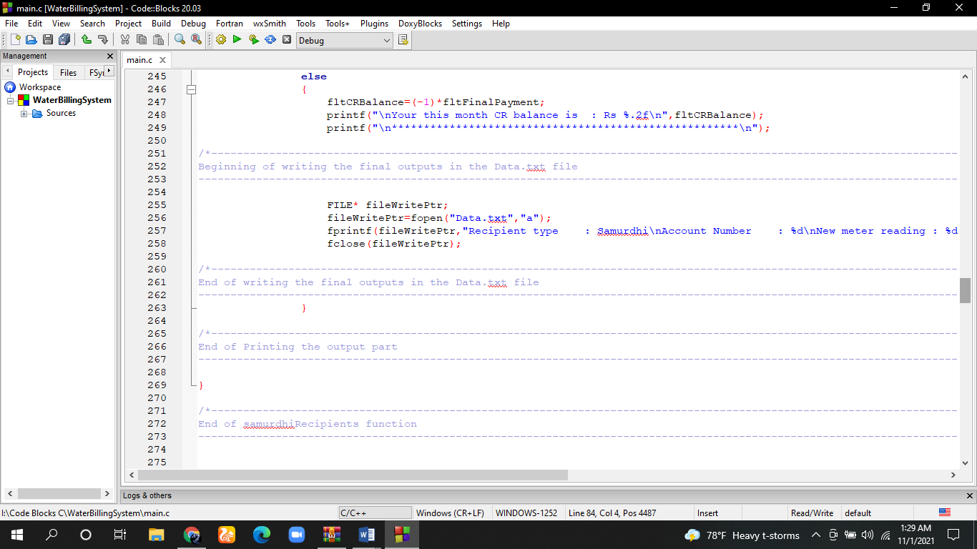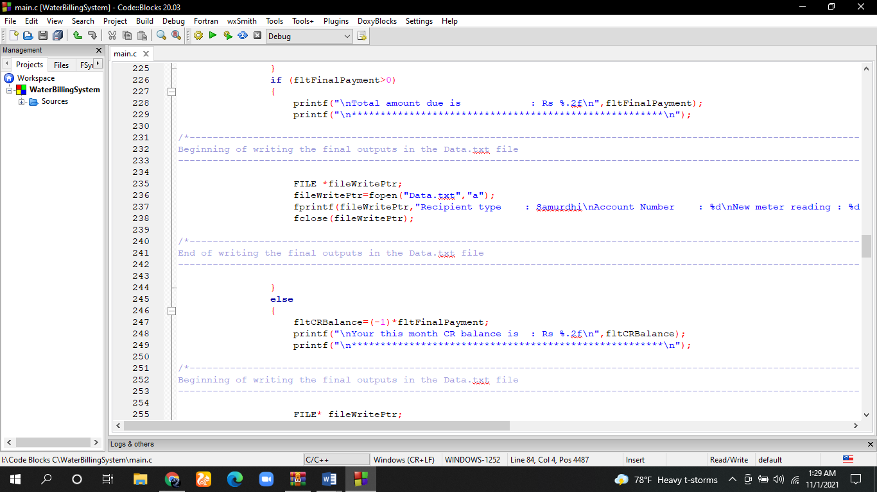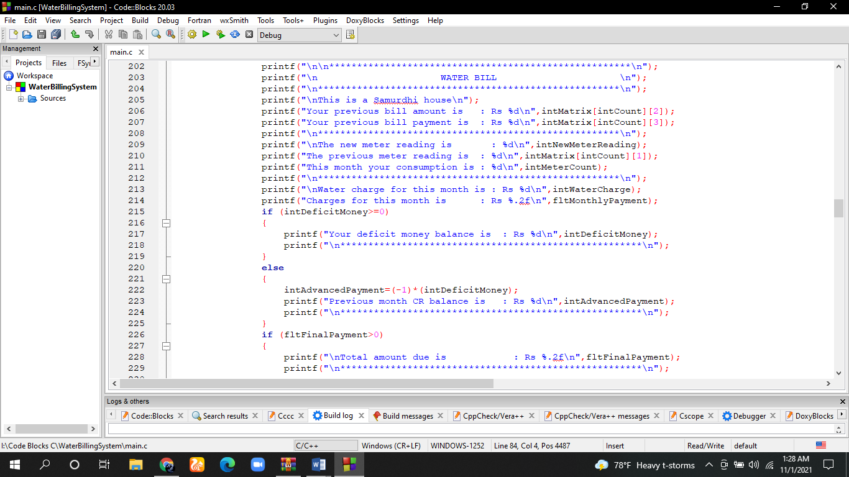

* Then we have written the final output.
* Also after declaring a file pointer and creating a “*Data.txt”* file we have saved the Recipient Type, New Meter Reading, Final Due Payment and if have instead of Due Payment we have saved the CR Balance in the file.

**NonSamurdhiRecipients Function**

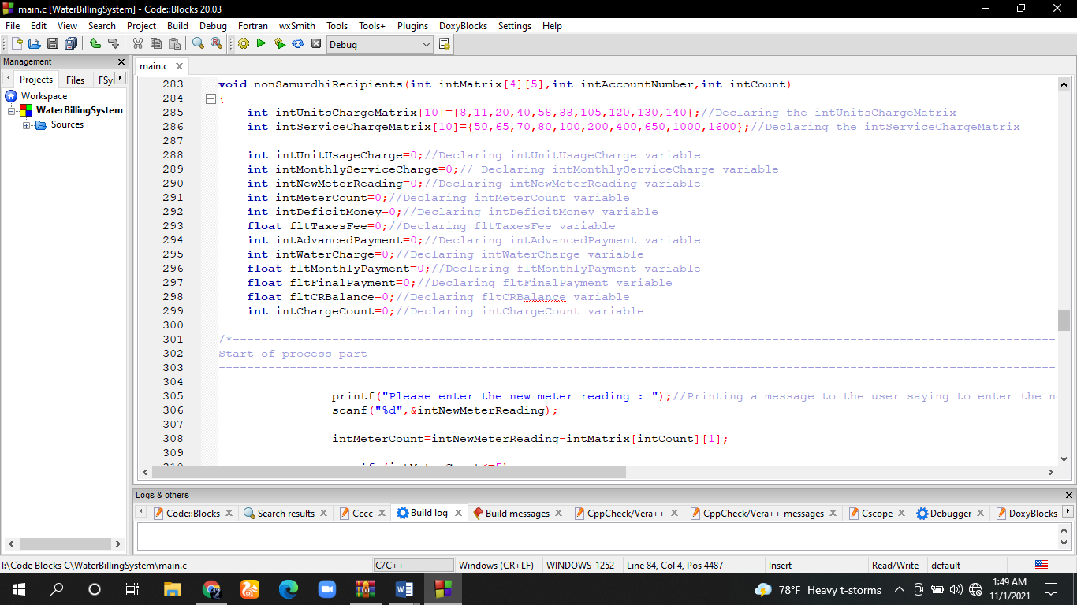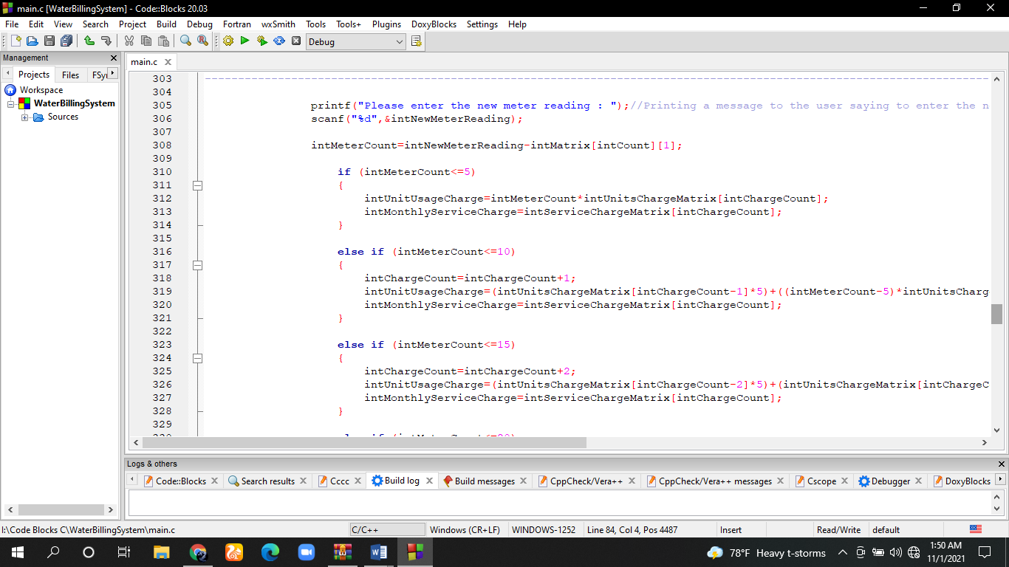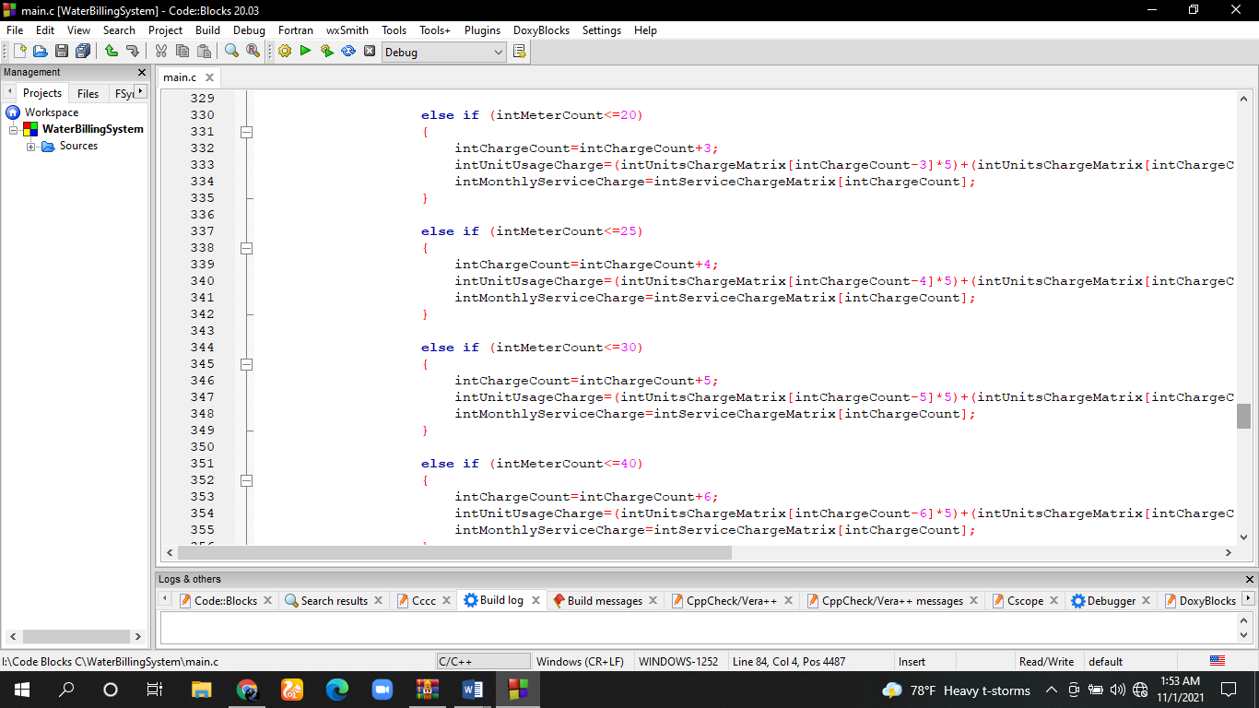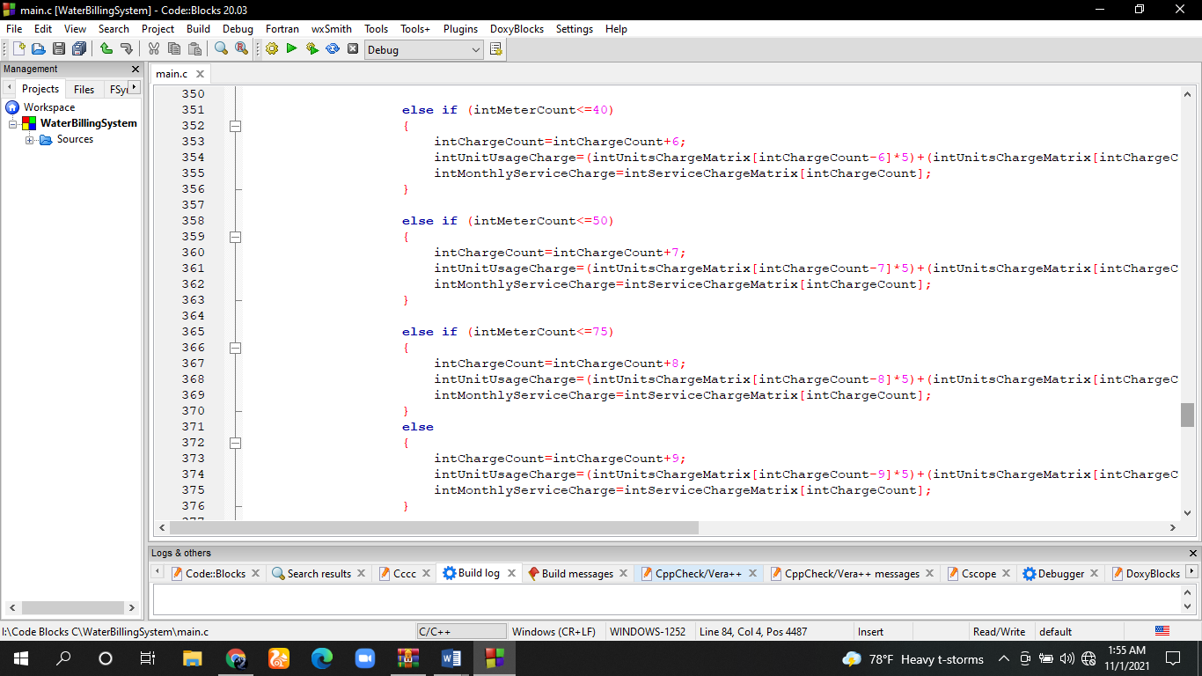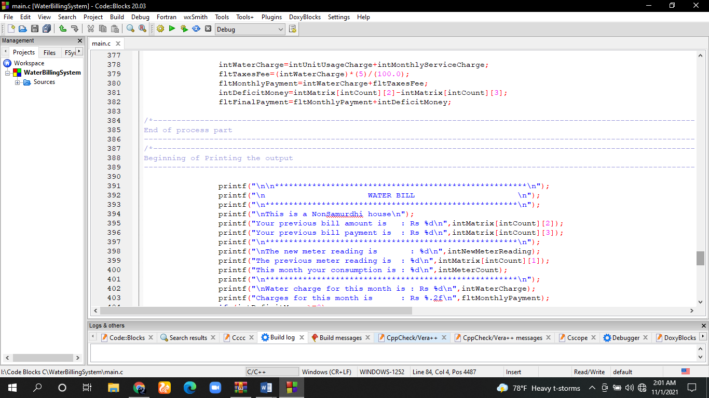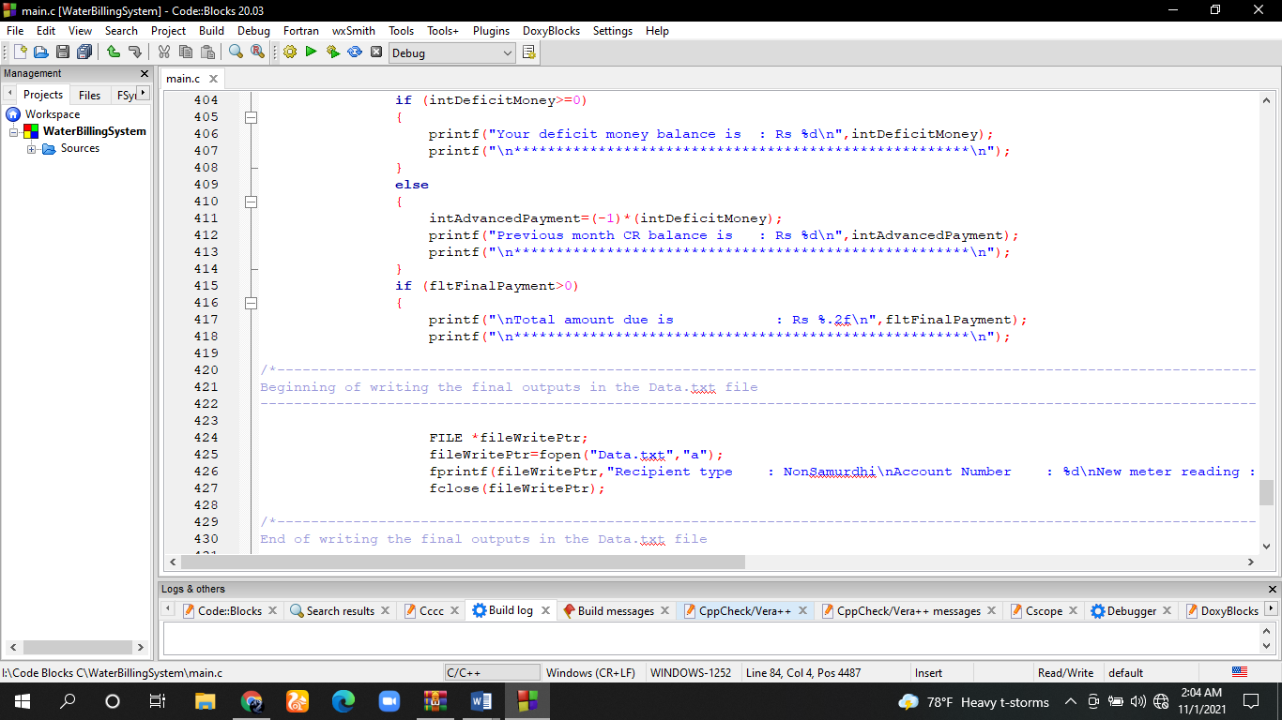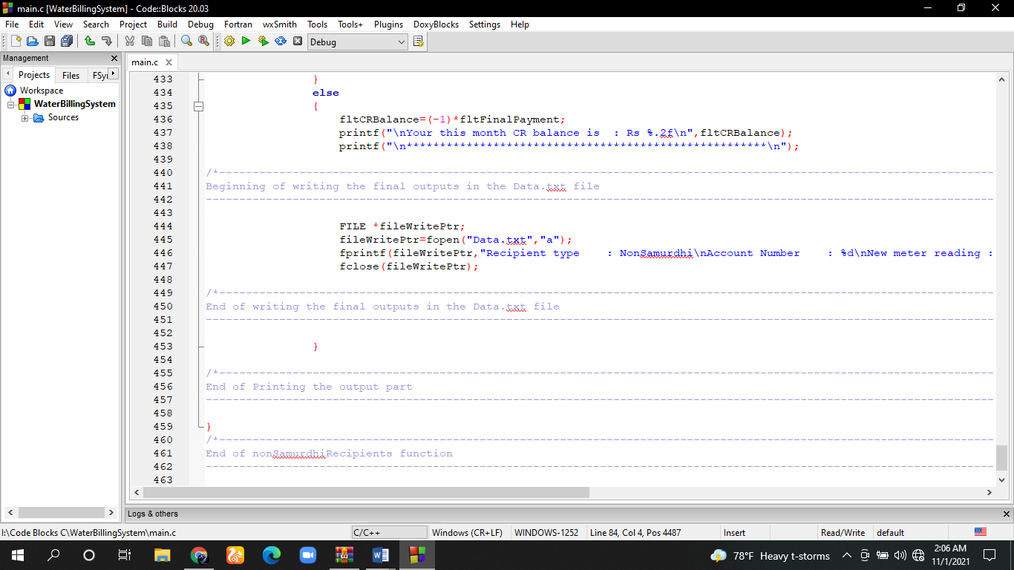

* In the NonSamurdhiRecipients function the same thing will happen in the SamurdhiRecipients function. Both have the same logic and similar output.
* In this function also “*Data.txt*” file will create and the same data will save inside it.
* The only change between this two function are the difference between the service charges rates and units charges rate.

So we hope this system will help you to do your work easily. If you have any kind of problem or a question about our system, feel free to contact us.

E-mail : [as2020961@sci.sjp.ac.lk](mailto:as2020961@sci.sjp.ac.lk)

Contact number : 071-7960831



**Programmers**

(We will bring your heavy work just under your fingertips)